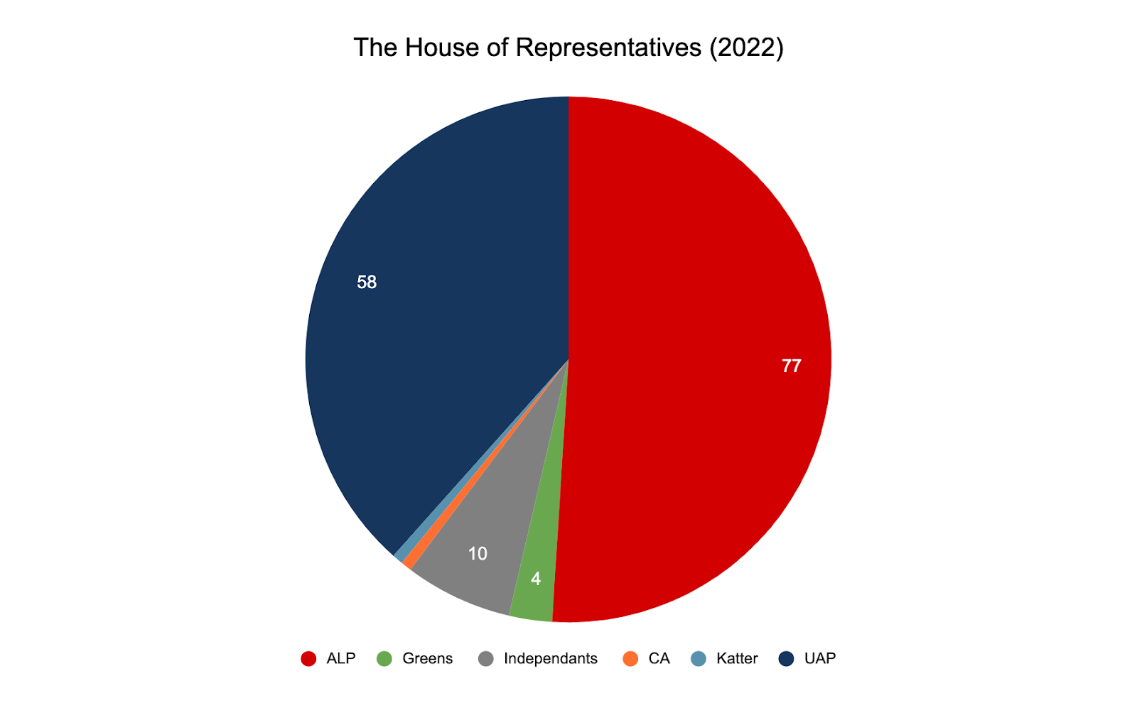
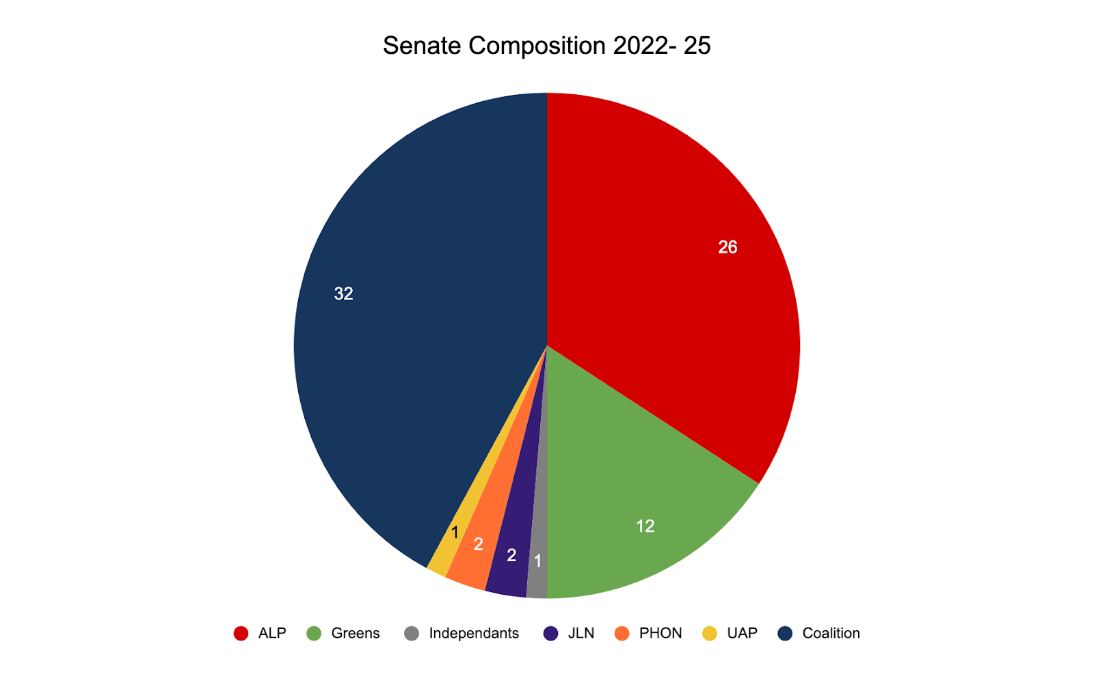

2019 House of Representatives Election Results
Party | 2022 Election | 2019 election | Seats Changed
ALP | 77 | 69 | - 8
LNP | 58 | 76 | - 18
Independents | 10 | 3 | - 7
Minority Party | 6 | 3 | - 3
2022 Senate Election Results
 | QLD | NT | ACT | WA | NSW | VIC | TAS | SA | Total
Coalition | 2 | 1 |  | 2 | 3 | 2 | 2 | 3 | 15
ALP | 2 | 1 | 1 | 3 | 2 | 2 | 2 | 2 | 15
Greens | 1 |  |  | 1 | 1 | 1 | 1 | 1 | 6
Other | 1 |  | 1 |  |  | 1 | 1 |  | 4
Total | 6 | 2 | 2 | 6 | 6 | 6 | 6 | 6 | 40
